**How to use external Script to monitor Service on Zabbix**

**Step 1: Enable External Script on Zabbix**

Root@localhost# vim /etc/zabbix/zabbix_agentd.conf

EnableRemoteCommands=1 (Uncomment this line)

**Step 2: Add UserParameter**

Root@localhost# vim /etc/zabbix/zabbix_agentd.conf

UserParameter= check_nginx[*],/etc/zabbix/script/check_nginx.sh

**Step 3: Create a Script to check**

Root@localhost# vim /etc/zabbix/script/check_nginx.sh

#!/bin/bash

check_nginx=`netstat -tunlp|grep nginx| wc -l`

if [ $check_nginx -ge 1 ];then

#if [ $(echo "$export_home2"|bc) -lt 1 ]; then

echo "OK - NO PROBLEM - mgf_68.44_NGINX SERVICE IS RUNNING"

else

echo "CRITICAL - mgf_68.44_NGINX SERVICE IS STOPPED"

fi

**Step 4: Test Script from Agent**

root@localhost# zabbix_agent -t check_nginx (check_nginx is key)

root@localhost#bash –x /etc/zabbix/script/check_nginx.sh

**Step 5: Test Script from Server Zabbix**

root@localhost# zabbix_get -s ip_address -p 10050 -k check_nginx

If it returns message like that

OK - NO PROBLEM - mgf_68.44_NGINX SERVICE IS RUNNING

==➔ Script working well

**Step 6: Add Monitor Service into Zabbix**

* Configuration ➔ Host ➔ Create Item



* Add item like image below

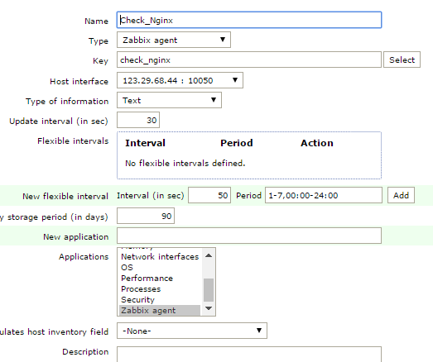

**Step 7: Create Trigger for this Item**

Trigger when message return with keyword CRITICAL

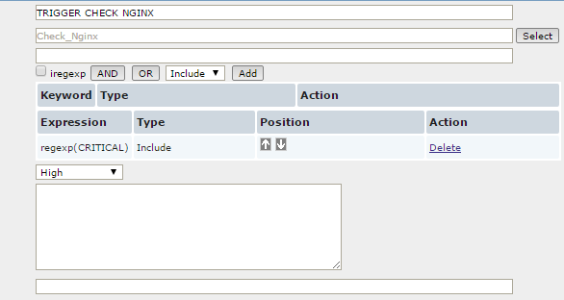

**Step 8: Finish and Enjoy Your Work !!**

**\*\* P/S** Above example is only for check_service, also check_storage, check_tomcat, check_apache, check_oracle is in the path 123.29.68.43: /etc/zabbix/script/